Ansible assignment 3 using roles-tomcat deploy sample war file
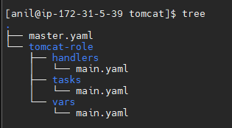
Master.yaml
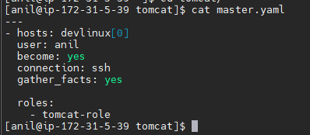
Tasks-main.yaml
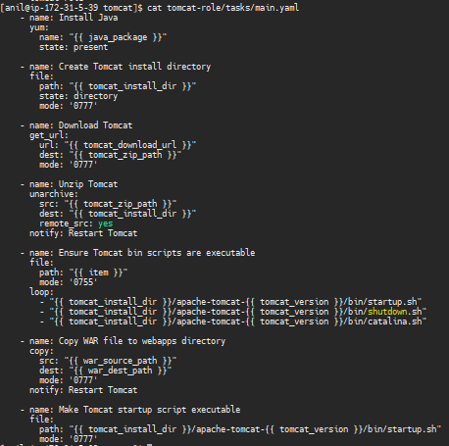
Vars-main.yaml
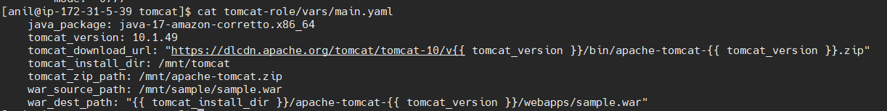
Handlers-main.yaml
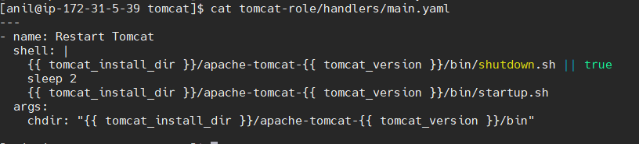
Ansible-playbook master.yaml
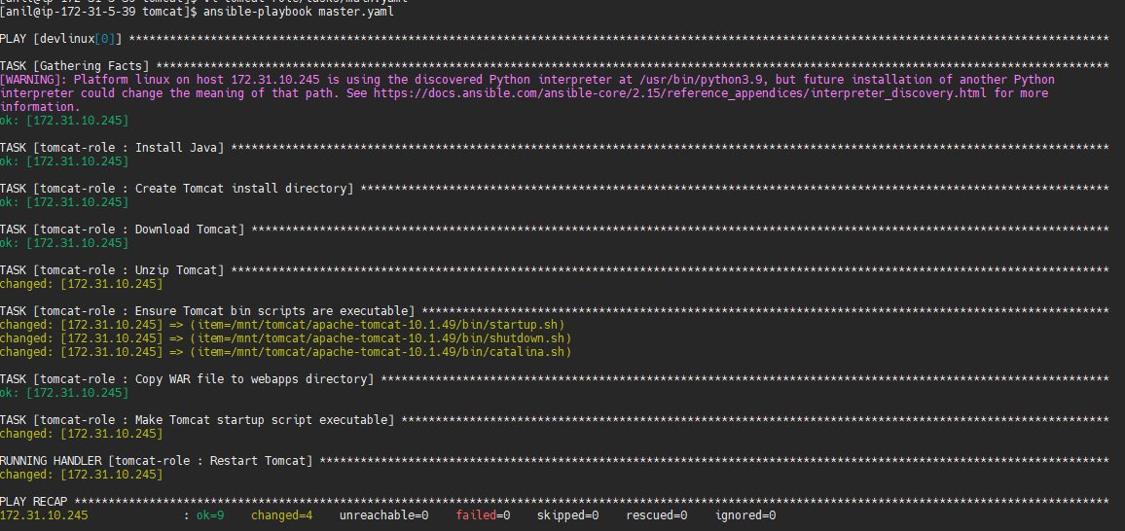
Output
